|  |  |  |
| --- | --- | --- |
| **LAB 321Assignment** | **Type:** | **LongAssignment** |
| **Code:** | **J3.L.P0020** |
| **LOC:** | **650** |
| **Slot(s):** | **15** |

**Title:** Mayfair Antique – store online

**Background**

### You want to startup with Mayfair Antique ,

Complete this assignment to know to write a online market to start your business now☺

Reference site:<http://us-123antique.simplesite.com/>

**Program Specifications**

Program a web site tointroduce your Mayfair Antique– store online, detail functions of this website is described below

**Features:**

This website contains 3 main functions

* Function 1 : Home page : ( see PIC 01)
  + Display introduction entry and top 3 product sorted by published date
  + Each productcontains
    - Entry name
    - Description picture
    - Entry description
* Function 2 : Online Store ( PIC 02)
  + List all item
  + When click button “add to basket” , your basket number is increase
  + When click button “check out”, display checkout form ( PIC 03)
* Function 3 : Our history ( PIC 04)
  + An entry tell about your service history
* Function 4 : Contact ( PIC 05)
  + Display contact information

You do not need to write interface for admin control panel, you can add data manually (use SQL SERVER Management studio).

Note: All data must be load from database, not hard code in page.

***Expectation of User interface:***

Pic 01 : Home Page

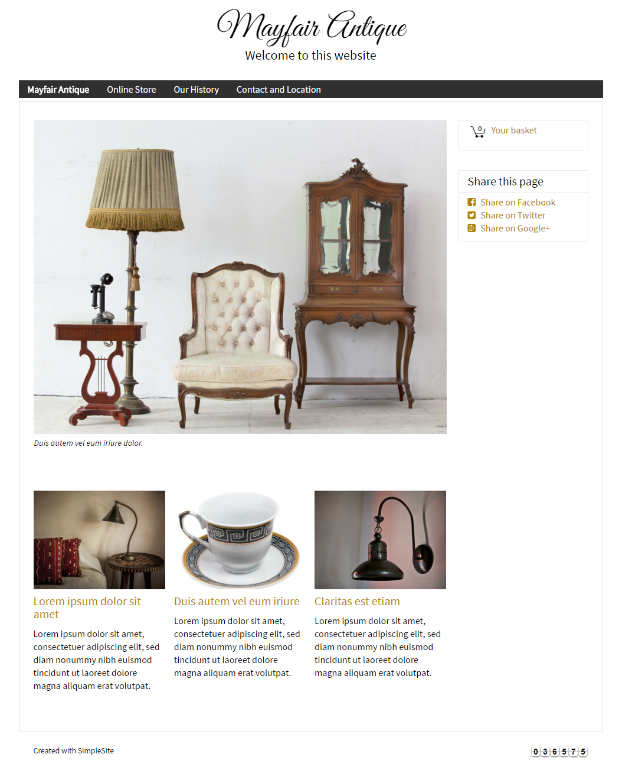

PIC 02 Online Store

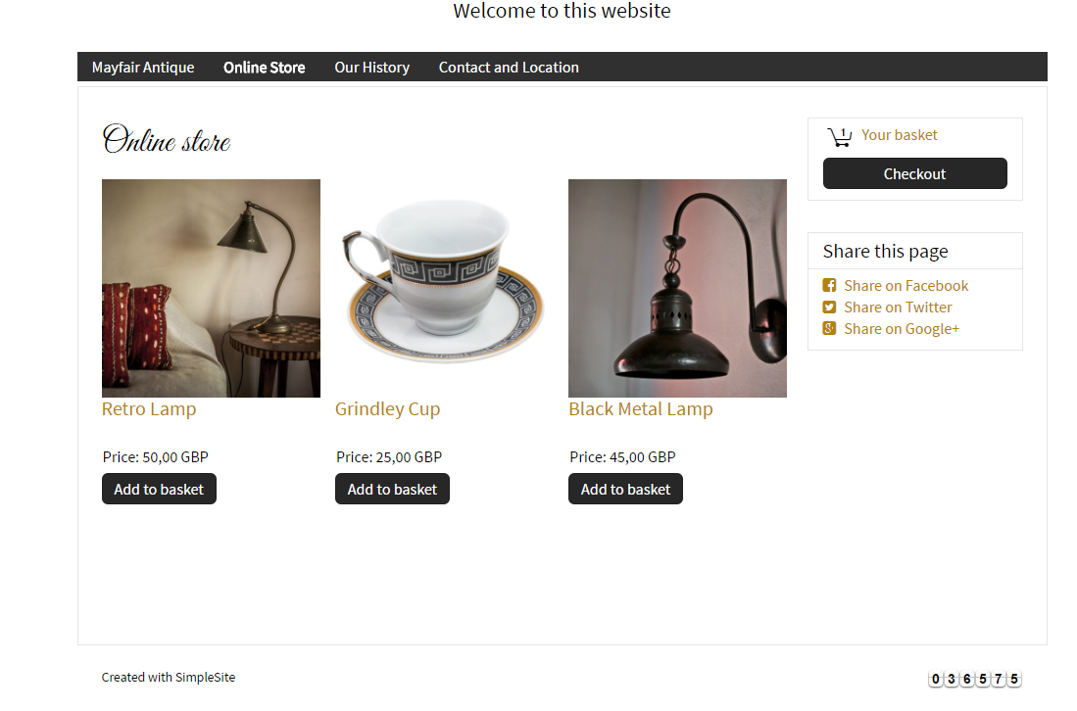

Description : When click to “Add to basket” , your basket number is increase .

PIC 03 When clicked to check out, display “check out form”

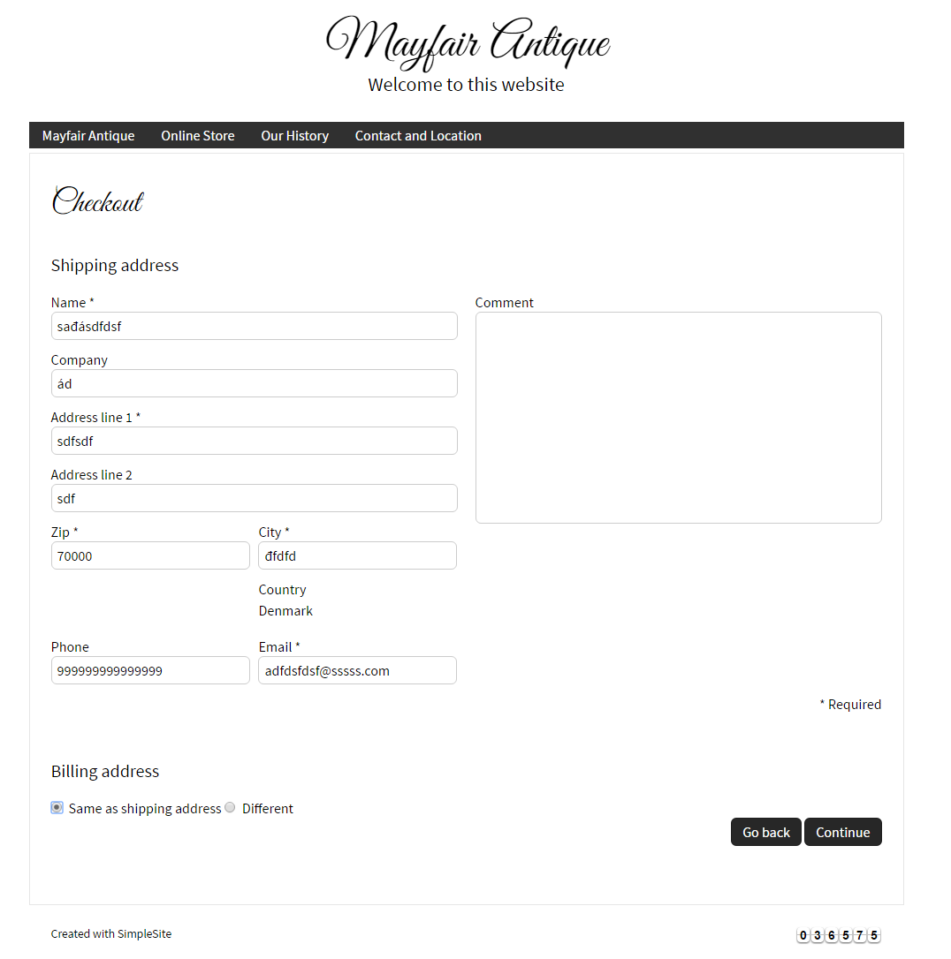

PIC 04 : Display company history

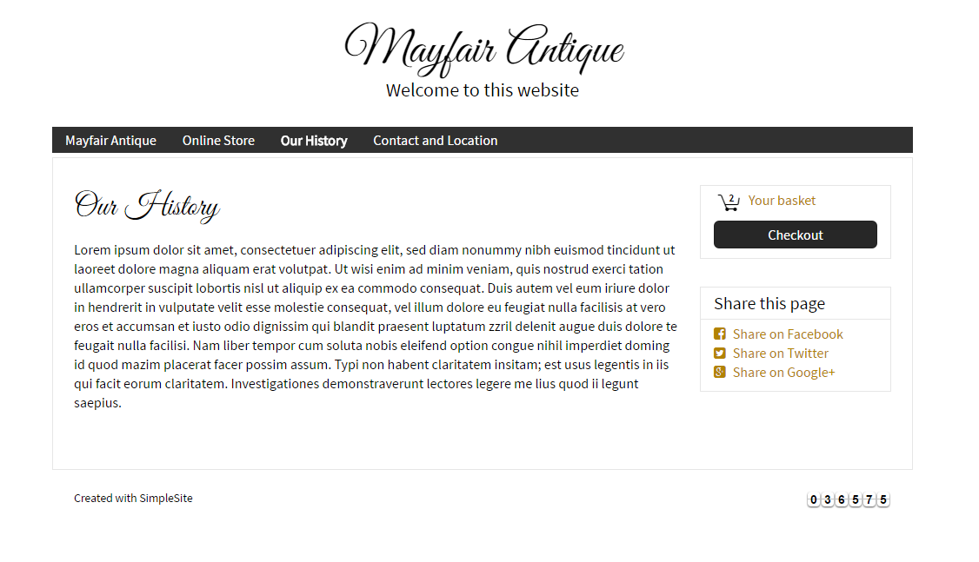

PIC 05 : Display company contact & location

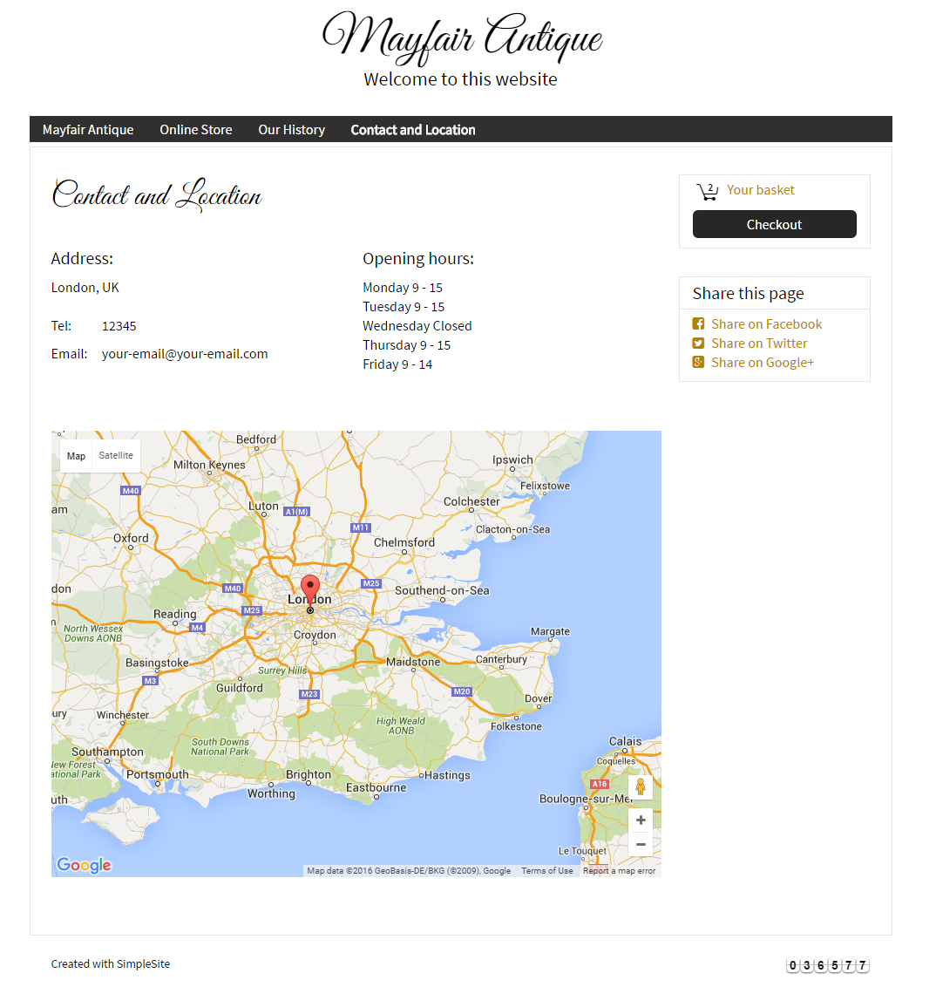

**Guidelines**

* Step 1 : Clarify requirement & scope with mentor
* Step 2 : Create prototype
* Step 3 : Design database base on created prototype
* Step 4 : Code & Test